Cisco NSO End-to-End Acceptance Test Guide
This document provides a step-by-step acceptance test procedure to verify that Cisco NSO (Network Services Orchestrator) is installed and functioning correctly. It covers checking the NCS server status, logging into the NSO CLI, validating device connectivity, confirming service package installation, committing service orders with payload data, and verifying results in both CLI and WebUI. Additional steps include log verification, OLT provisioning in Tejas EMS, and deletion of committed orders to ensure complete lifecycle validation
1.NCS Status
ncs –status : check nso status and version
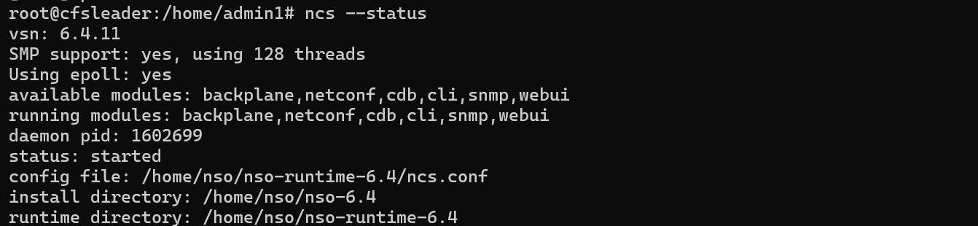
2. Login to NSO CLI
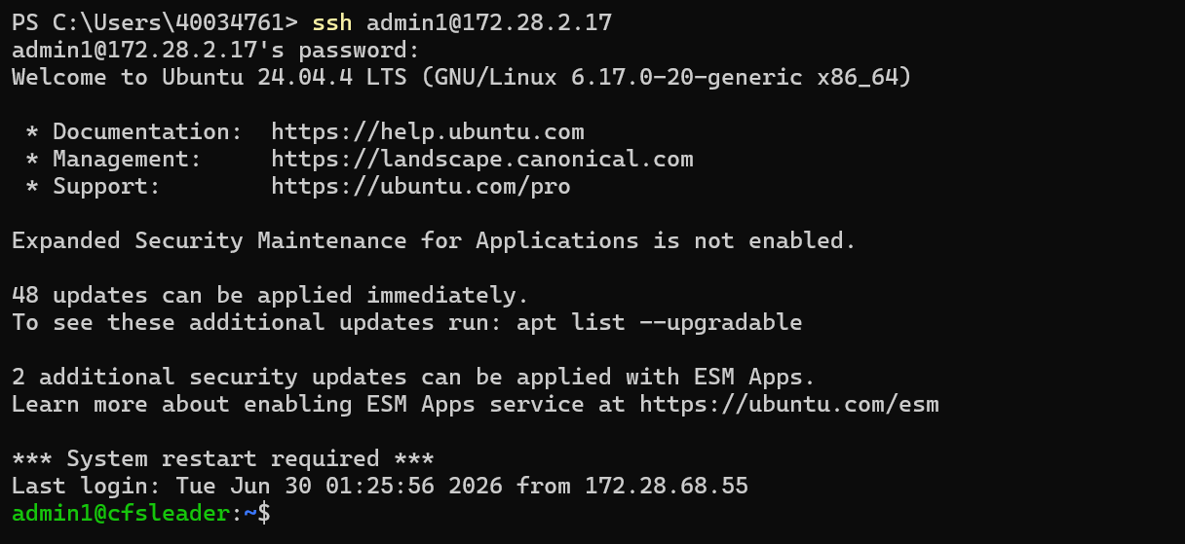
ncs_cli -u admin -C : start the Cisco NSO Command Line Interface (CLI)

3. Check Devices Connectivity
Unit test: verify devices are reachable.
show devices list
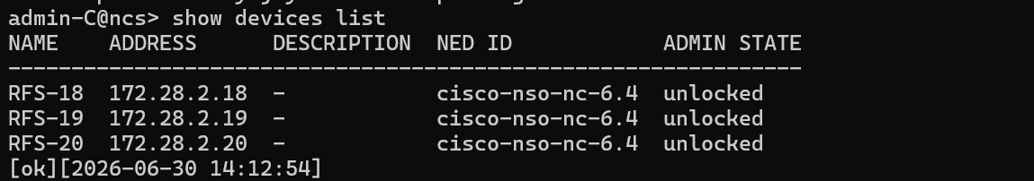
show devices device <DEVICE_NAME> state
4.Validate Service Package Installation
Unit test: confirm your service package is loaded.show packages package oper-status
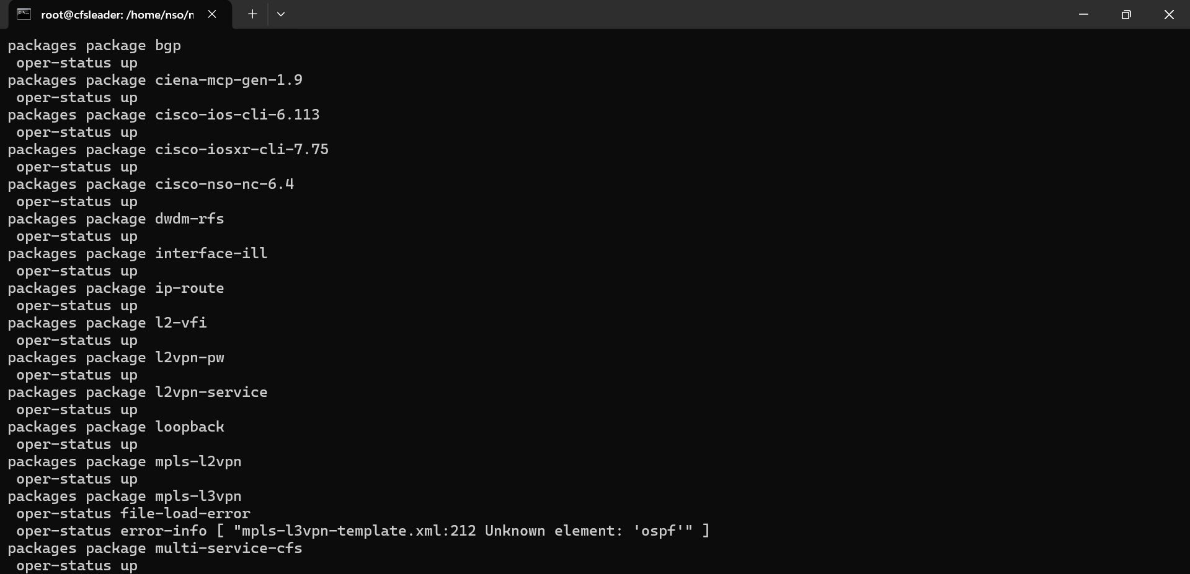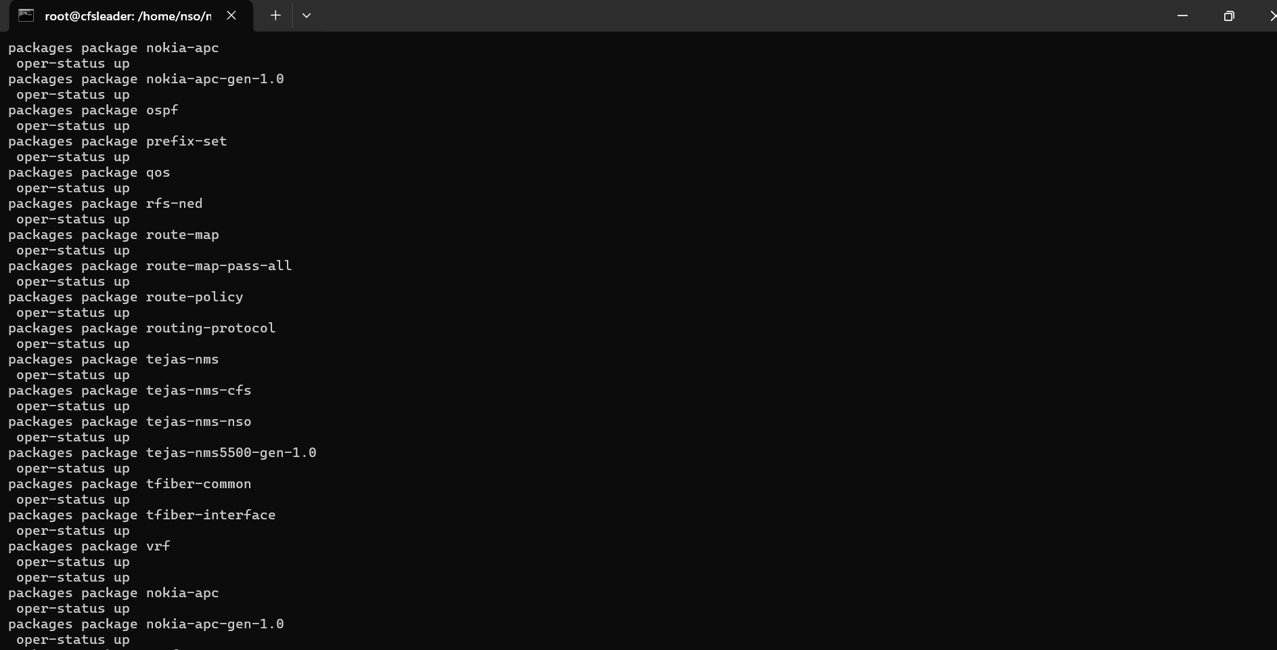
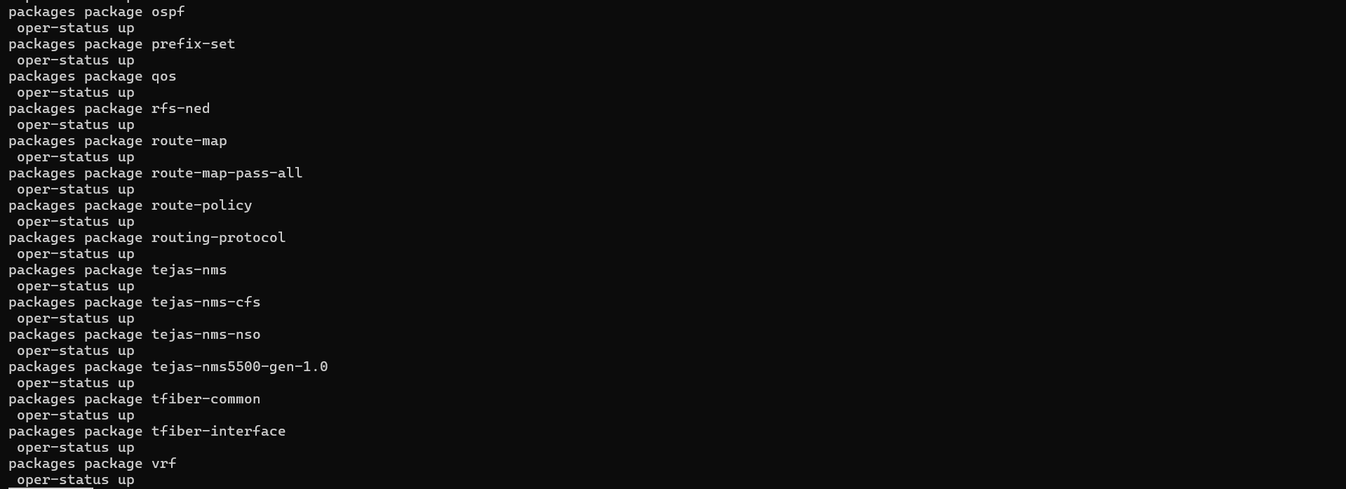

5.Committing Service Order for tejas-nms-nso-cfs:tejas-nms-nso-cfs
Enter to Config Terminal : config terminal and enter the payload steps
Payload : {
"tejas-nms-nso-cfs:tejas-nms-nso-cfs": [
{
"device": "tejas-ems-pkga",
"service-id": "Tik10012-GPON-300626022237",
"package": "A",
"olt-ip": "172.17.128.38",
"pon-port": "1|1|11",
"ont-serial": "TJNW95D01B1D",
"ont-model": "TJ2100N-11G",
"ont-port-instance": "4",
"c-vlan": "3000",
"s-vlan": "3000",
"customer-id": "GOV/ITC/001",
"upstream-bandwidth-profile": "UP_GI_30M",
"downstream-bandwidth-profile": "TejNMS-DN_GI_30M",
"provisioning-mode": "bridge",
"vlan-tagging": "tagged"
}
]
}

6.Commit was Successfull
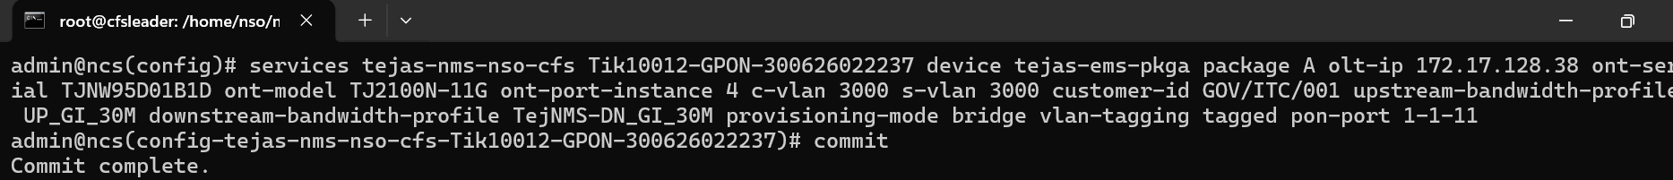

7.Committed order can be seen in the NSO WebUI OF CFS
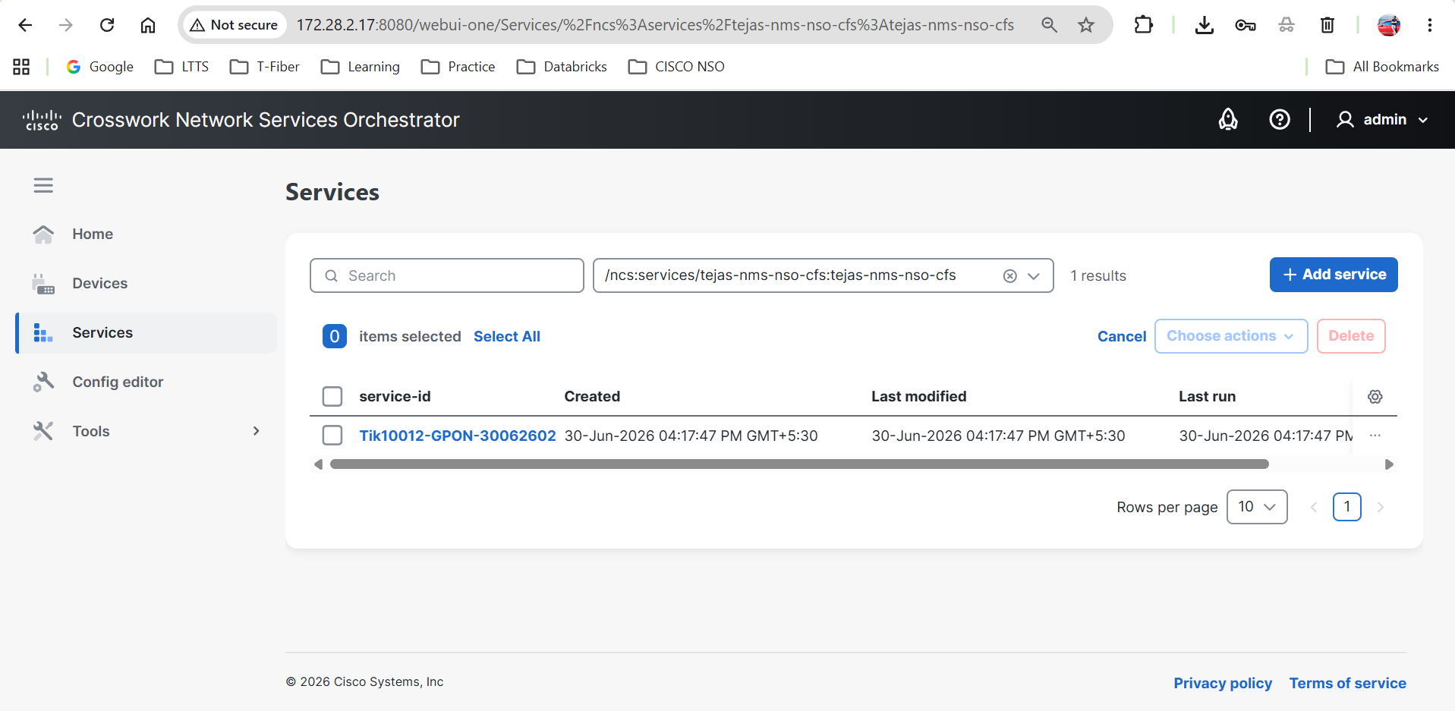

8.Committed order can be seen in the NSO WebUI OF RFS
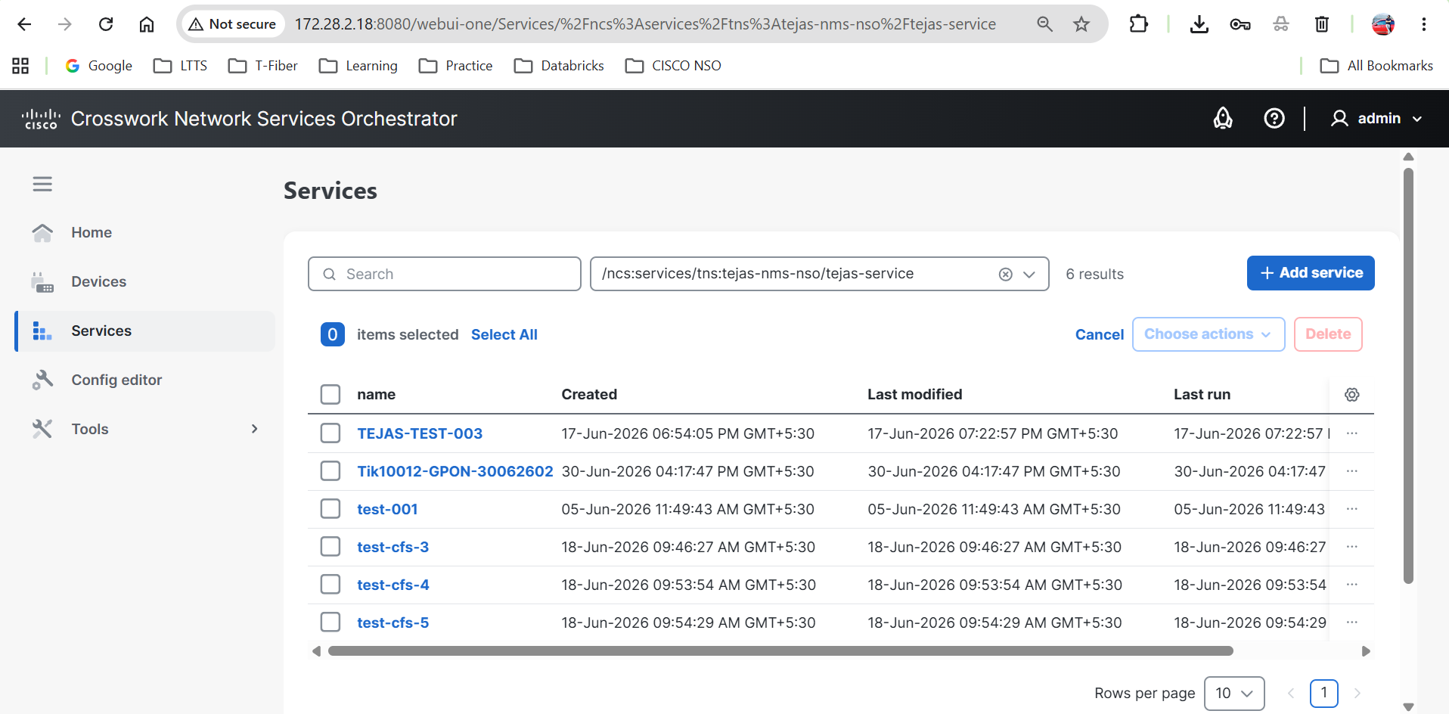

9.Logs of Committed Order in CLI
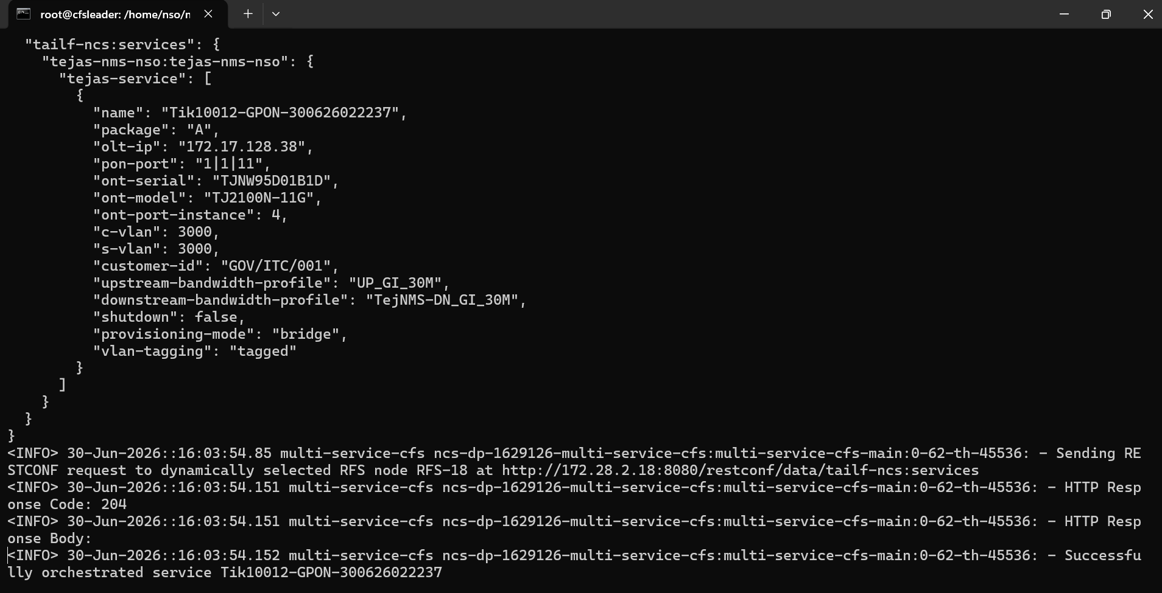

10.OLT Provisioning in Tejas EMS
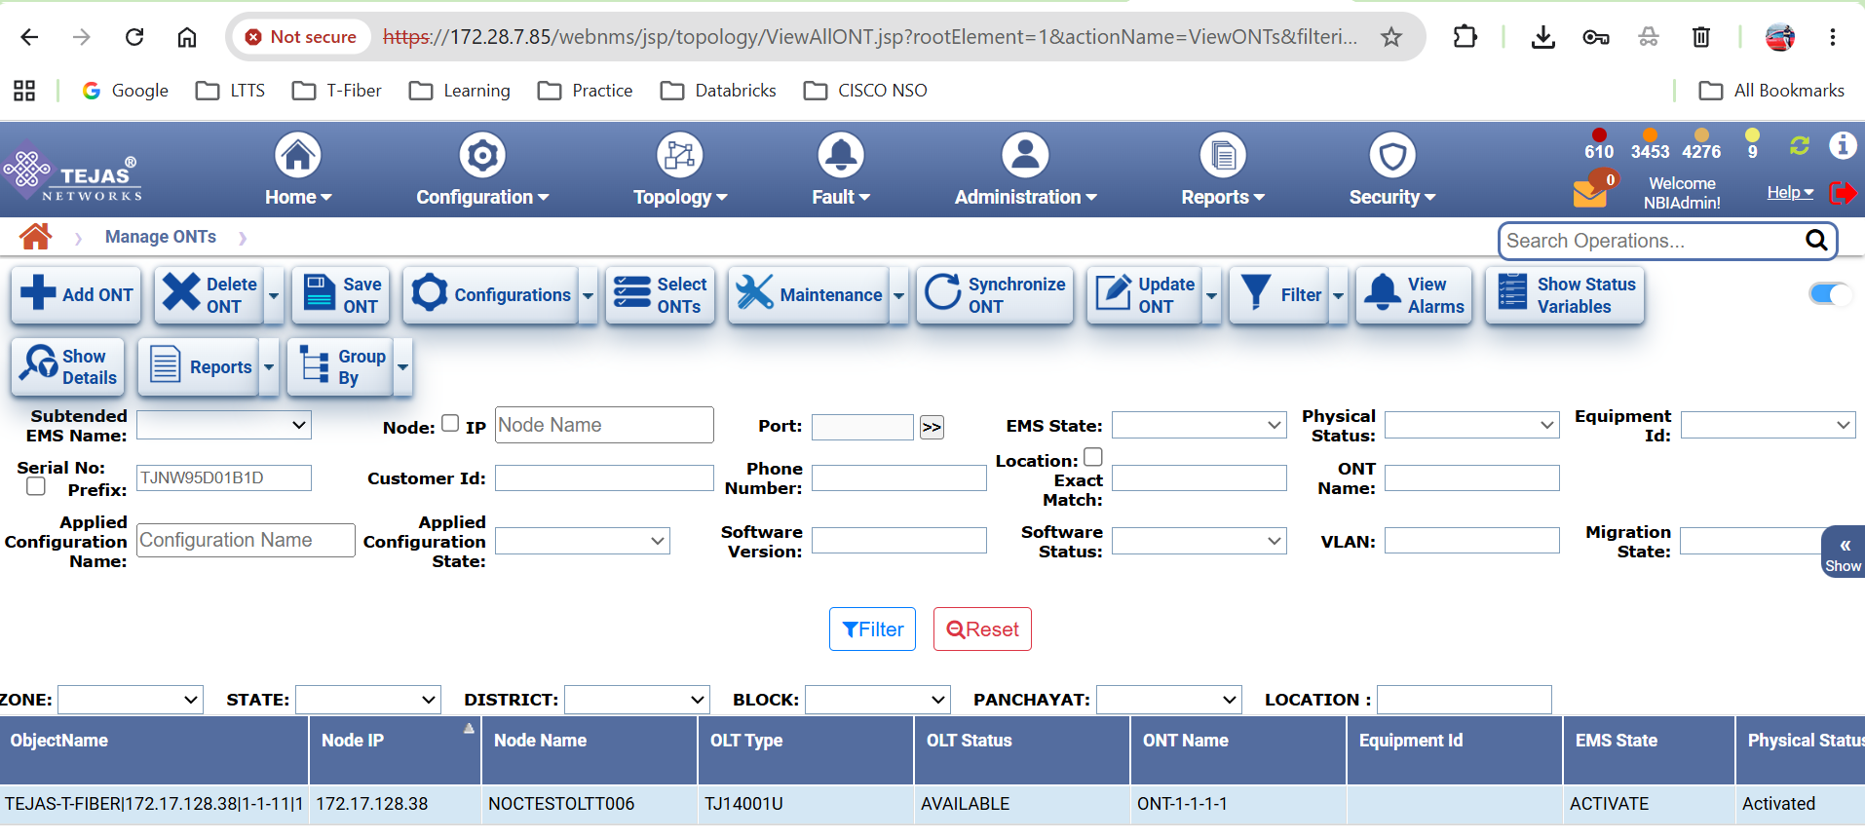

11.Deletion of Committed Order
